
Databases & Analytics
Assignment 1

Module Tutor: Dr Shidrokh Goudarzi
Submitted By: Ayush Jethwa
Student ID: 34104138
Course: Computer Science

Link to GitHub Repository:
https://github.com/ayjet24/dba-assignment

2026

Table of Contents

Introduction 3
NorthStar Urban Mobility and Logistics Problem Analysis 3
Dataset Overview 5
Python Data Processing and Findings 7
SQL in R and R Analytics Data Processing and Findings 16
SQL in R: 16
R Analytics and Visualisation Findings: 21
MongoDB Atlas and PyMongo Findings 25
Conclusion 35

Introduction
A fragmented data system, growing customer complaints, delays, missed delivery windows, vehicle breakdowns and inconsistent reliability across city zones are causing NorthStar Urban Mobility and Logistics to experience operational inefficiencies. Structured operational data is stored in traditional systems, while semi-structured data on mobile platforms, drivers, sensors and complaint data cannot be analysed with relational methods alone.

This assignment analyses NorthStar’s dataset using Python, R, SQL and MongoDB Atlas to identify major operational problems and an appropriate NoSQL database solution was designed. The Python programming language is used for data cleaning, feature engineering and visualisation. The SQL language is used in R to query data that is structured optimally. Analysing and visualising data is done with R. In MongoDB Atlas, versatile records such as exceptions, route events, complaints and interactions between apps are stored. Optimising queries is demonstrated by indexing and explaining plans.

NorthStar Urban Mobility and Logistics Problem Analysis
The following are some of NorthStar’s current challenges:
- The data is fragmented across various departments
  - Resulting in unproductiveness for NorthStar since it is difficult to gain a complete understanding of operations.

- Failure to complete a journey or deliver a package
  - NorthStar’s reputation is damaged because of decreased customer satisfaction.

- A lack of proper linkage between complaints and service records
  - Ensures that repeated issues are not settled productively.

- Poor route planning may be reflected in route overrides.
  - Costs more to operate due to increased fuel and labour costs.
- Problems with vehicles and maintenance issues are spotted late
  - Resulting in service interruptions, high repair costs and breakdowns.

- Systems do not use charging hubs consistently
  - Slows the operations of electric fleets due to inefficient use or bottlenecks.

- Dispatching volumes may appear efficient but leads to complaints later in the process
  - Customers become frustrated whereas management believe processes are productive

- Costs are rising quicker than the revenue
  - NorthStar’s sustainability and revenue efficiency are endangered.

- In current relational systems, app events, messages, GPS logs and case histories are difficult to manage
  - This limits the ability to make evidence-based choices and hinders visibility into operations.

Based on the above issues, my analysis will examine the following:
- Delay trends
- Failure trends
- Complaint trends
- City and zone performance
- Service type performance
- Warehouse performance
- Vehicle inactivity
- Cost and revenue problems
- Customer unhappiness

Dataset Overview
DATASET | ROWS | COLUMNS | PRIMARY GOAL | DATA INCONSISTENCIES
Incidents | 280 | 7 | A log of delivery-related incidents, including their types, severity levels and settlement statuses, as well as the timeline for their resolution. | There are 17 values related to ‘resolved_hours’ that are missing.
Orders | 1250 | 11 | Details about the service order, such as the customer, the type of service, the expected time window, the zones, the priority, the value and the booking channel are stored. | There are 25 values related to ‘booking_channel’ that are missing. The zone formatting is inconsistent (‘Airport’, AIRPORT’, ‘South’, ‘SOUTH’, ‘RiverSide’, ‘Riverside’.
Vehicles | 120 | 8 | Stores data on assets, such as the type of vehicle, the assigned zone, the date of commission, battery condition, mileage, maintenance status and telematics version. | There are 4 missing values related to ‘battery_health_pct’.
App Events | 640 | 10 | Information related to route searches, ETA updates and chat interactions with customers and apps. | There are 144 values that are missing related to ‘order_id’.
Complaints | 320 | 10 | The complaint database includes information about the type of complaint, seriousness, status, closure time and compensation. | There are 16 missing values related to ‘compensation_amount’.
Customers | 650 | 9 | Customer details such as their age, home zone, type of customer, loyalty and engagement ratings are stored. | There are 20 missing values related to ‘loyalty_scores’ and 13 values related to ‘preferred_channel’.
Data Dictionary | 9 | 3 | Describes the dataset files, record counts and descriptions. | There are no recorded values that are duplicated or missing.
Deliveries | 950 | 13 | The database contains information about delivery operations, including drivers, vehicles, hubs, dispatch times, delivery status, route distances, ratings and costs. | There are 19 missing values related to ‘delivery_completed_at’ and 14 values related to ‘customer_rating_post_delivery’.
Drivers | 170 | 8 | Driver details such as their rating, training score, experience and employment type are stored. | There are 7 values related to ‘training_score’ that are missing.
Hubs | 8 | 5 | Hub data including the name, zone, type of hub and capacity score are monitored. | There are no missing values or duplicates.

Python Data Processing and Findings
Python was chosen to load, investigate, clean and evaluate CSV datasets for NorthStar. I imported the datasets directly from GitHub into Google Colab using pandas. The CSV files were no longer needed to be uploaded manually to my notebook every time I opened it, so my workflow was more consistent.

Upon inspection, I located 10 CSV files. These included:
- App Events
- Complaints
- Customers
- Data Dictionary
- Deliveries
- Drivers
- Hubs
- Incidents
- Orders
- Vehicles
It was deliveries that had 950 records and orders that had 1250 records, which were the largest datasets. Based on this, NorthStar’s data consists primarily of order and delivery activity.
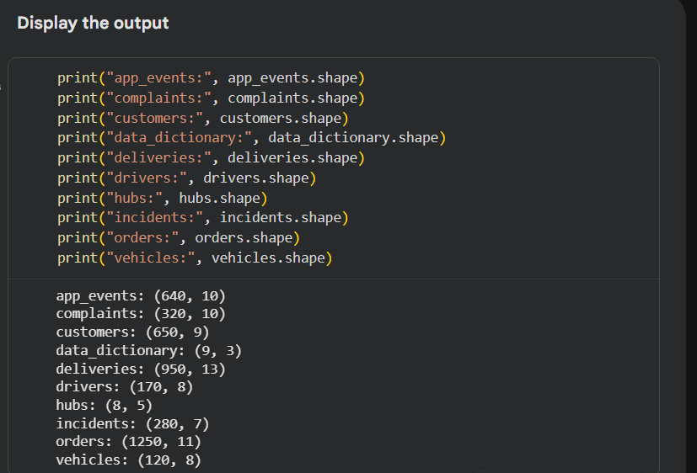

Furthermore, none of the datasets contained rows that were duplicated. However, a few values were missing:
- ‘app_events’ was missing values for ‘order_id’ values.
- ‘customers’ was missing values for ‘loyalty_score’ and ‘preferred_channel_values’.
- ‘deliveries’ was missing ‘delivery_completed_at’ and ‘customer_rating_post_delivery’.
- ‘vehicles’ was missing ‘battery_health_pct’ values.
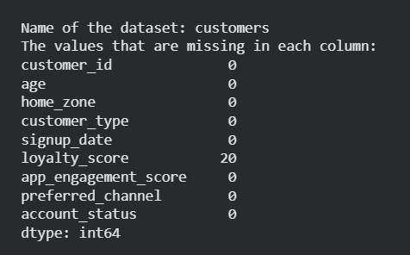

A data cleansing process was performed to ensure that the data was more accurate and suitable for analysis. Rather than deleting unfinished records, missing values that were text-only were replaced with “not known”. A median value was used to replace missing numbers because this value is not as affected by abnormally high or low values. The clean-up process was followed by a missing values test which validated that the cleaned datasets had no missing values. As a result, the analysis for Python and visualisations were more reliable. It was necessary to remove spaces from the text columns and to make them lowercase. By doing so, specific values could be compared because they had duplicates (North / north, Airport / AIRPORT). Here are some screenshots of the data after it was cleaned:

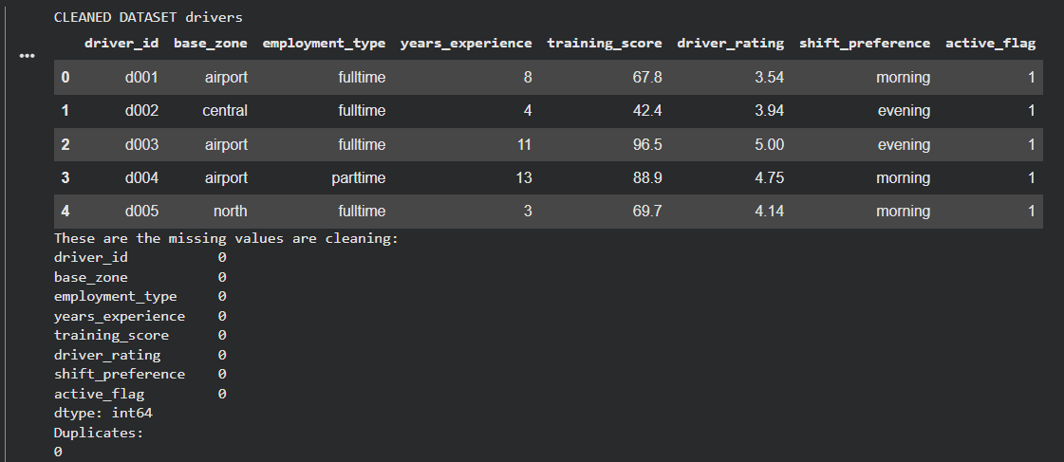
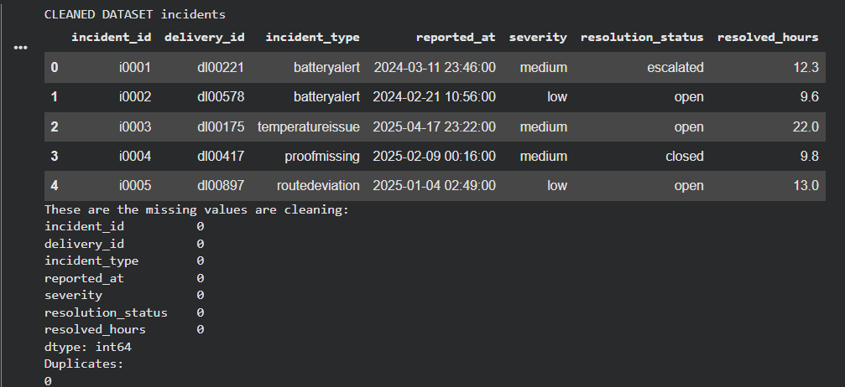

For analysing NorthStar’s issues operationally, I implemented 5 bar charts.

The first chart shows the vehicle battery health by maintenance status. In this way, it is possible to determine if vehicles under repair have poorer battery health condition than vehicles that are active. In the chart, it is visible that vehicles that are active and in repair both have the same battery health average. As a result of rising vehicle downtime and late detection of maintenance issues, this is relevant.
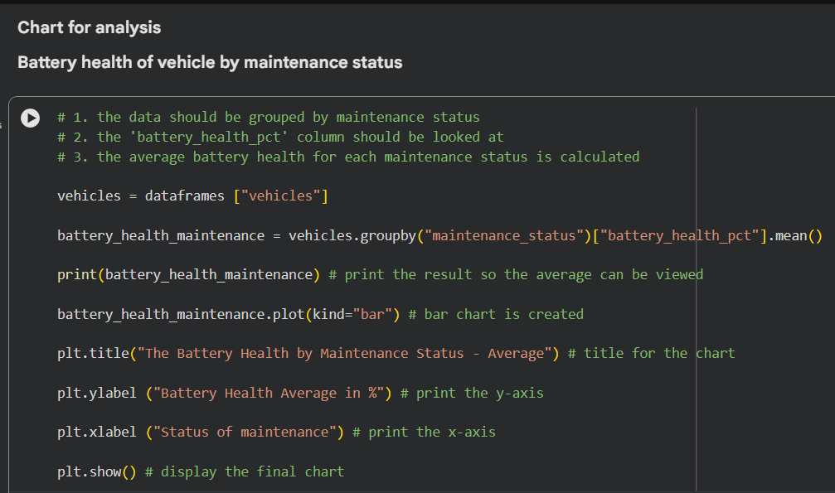
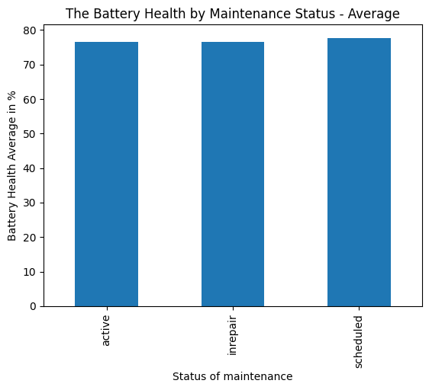

The second chart shows the main factors for customer unhappiness. Using this data, NorthStar can determine why complaints are rising, whether it is due to delays, issues with the app, missed pickups or different issues operationally. The chart shows that the most complaints were due to delays, where over 100 customers complained about this.

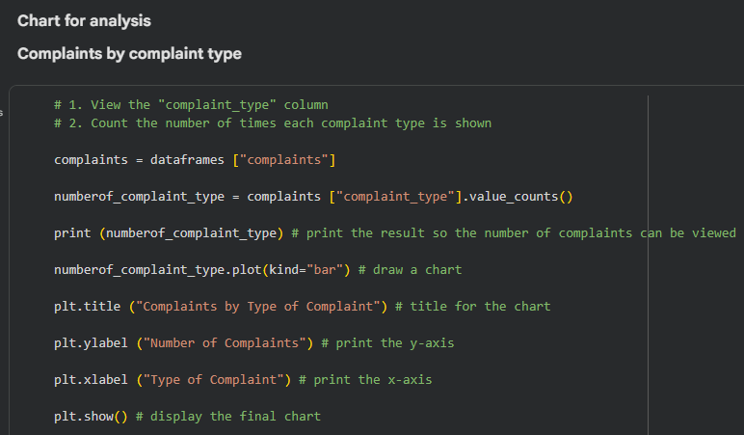
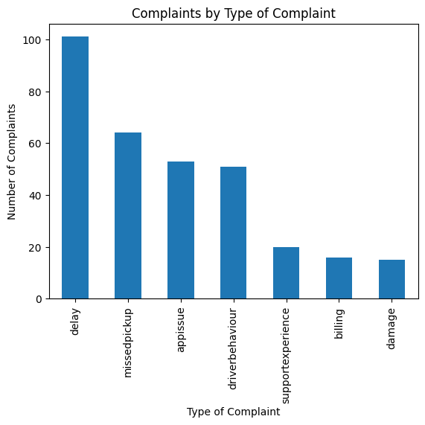
The third chart reveals how ratings from customers change based on whether their delivery was on time, delayed or failed. In this way, it is possible to determine if unsatisfactory delivery performance is associated with lower customer satisfaction levels. As shown in the chart below, a very high rating was given when the delivery was delivered on time, but when a delivery was delayed or failed, a rating of 3.0 was the average.

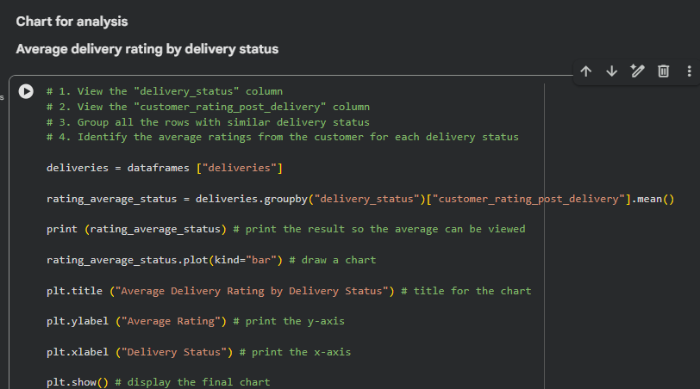
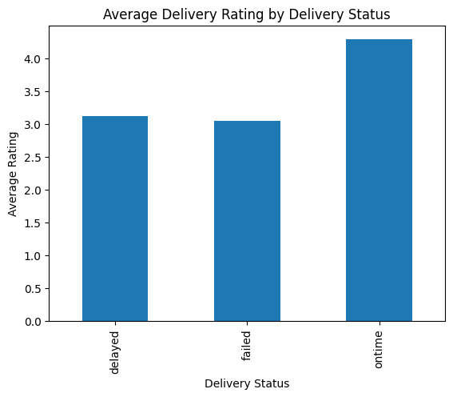
The next bar chart is a delivery status count, which analyses a dataset of deliveries to identify the number of deliveries that fall into each status category. These include being on time, delayed or failed. As shown in the chart, around 600 deliveries were delivered on time and around 132 failed. This is important to know for NorthStar so they are aware of what to do in case the number of deliveries that are failing increases.

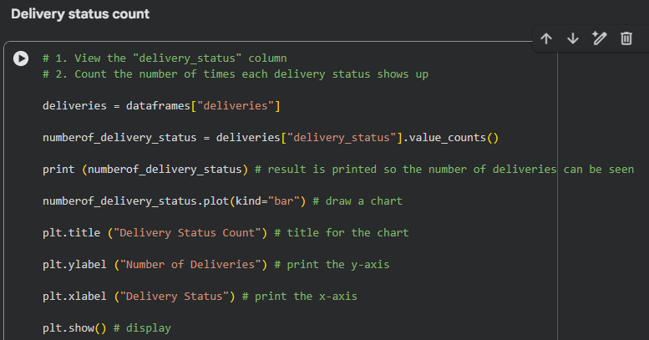
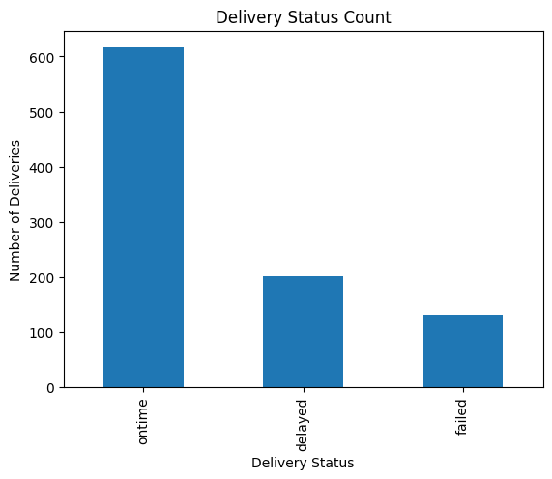

The next chart was a joined analysis by using ‘order_id’ and merging the delivery and order datasets. Using this method, it was possible to look further into delivery performances and other data which includes priority level and the type of service. As seen in the chart, the ‘passenger’ service type was the most successful in terms of being on time and having the highest number of deliveries. ‘service_type’ and ‘delivery_status’ were grouped together to visualise the number of deliveries that were on time, delayed or failed for 5 different services. According to the case study, NorthStar’s issues are linked across various system instead of being secluded.
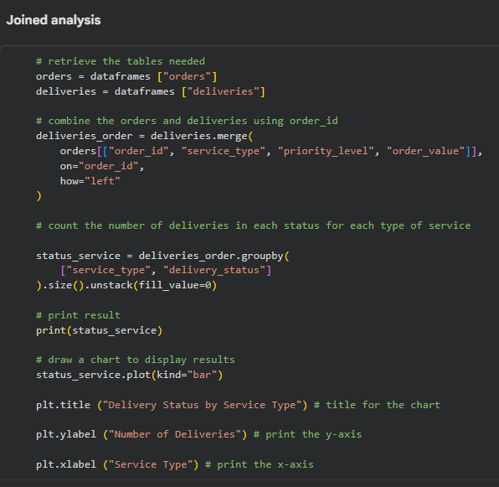
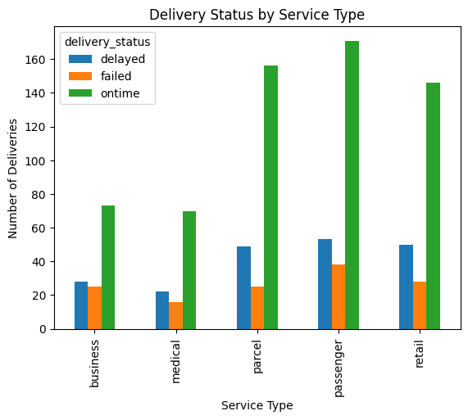
Based on the Python analysis I conducted for NorthStar, the main faults are related to customer service/complaints, unfinished operational records, vehicle conditions and service reliability.

SQL in R and R Analytics Data Processing and Findings

SQL in R:
The use of SQL was done through loading the cleaned NorthStar CSV files directly from GitHub into R through the read.csv() function. These datasets were then written in an SQLite database with the use of dbWriteTable(). The SQLite database held 9 primary tables namely app_events, complaints, customers, deliveries, drivers, hubs, incidents, orders and vehicles. This was done to confirm that the datasets are successfully cleansed for querying inside R.
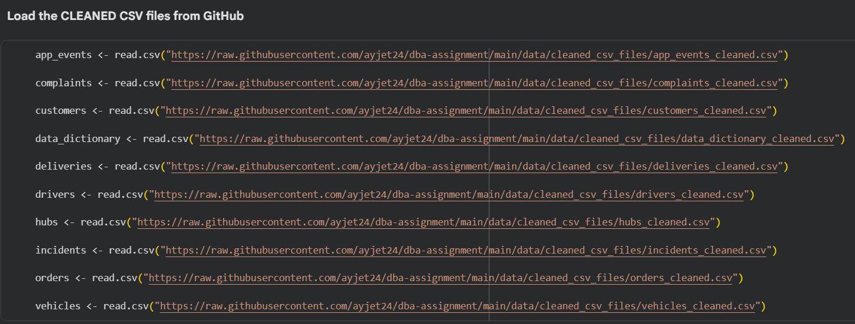

To make sure that the database connection works and the tables were created successfully, a basic SQL was used to pull some records from the orders table. The output for this query which was SELECT * FROM orders LIMIT 5 provided the first 5 records from this table, which proves that the connection and tables can successfully extract the required table.
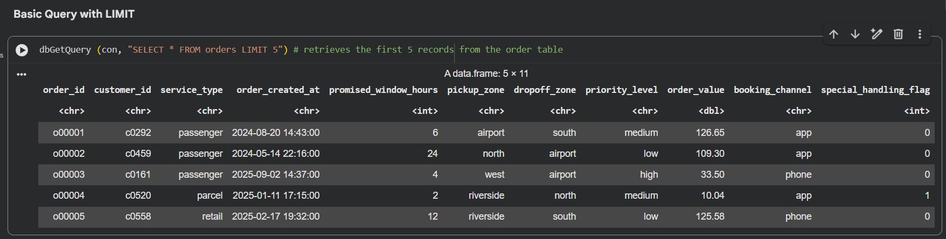

In the next part, the first analysis was done by counting the number of orders per service_type. This analysis produced the following results: passenger – 341 orders, parcel – 308 orders, retail, 297 orders, business – 165 and finally medical 139. It can therefore be concluded that passenger, parcel and retail services have the most orders and represent the largest market segments.
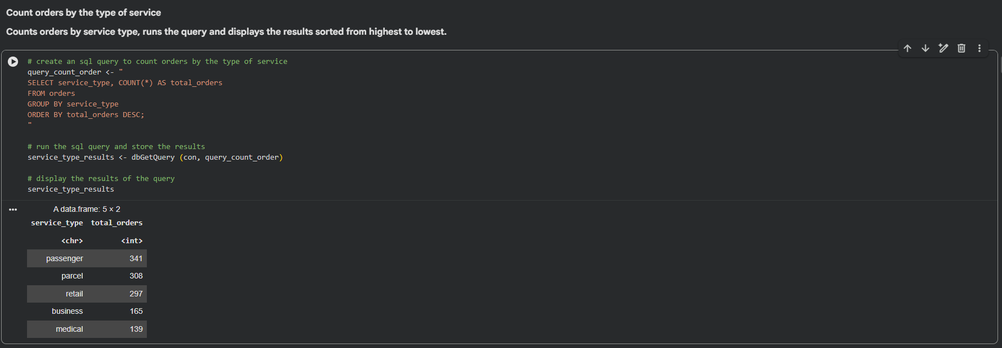

An additional SQL statement tallied the number of deliveries based on their delivery status. The findings were 616 on time deliveries, 202 delayed deliveries and 132 failed deliveries. The significance of the finding is seen in the case study that shows that NorthStar is facing delays and delivery windows being missed. The evidence provided above is that there are some deliveries that are not on time.
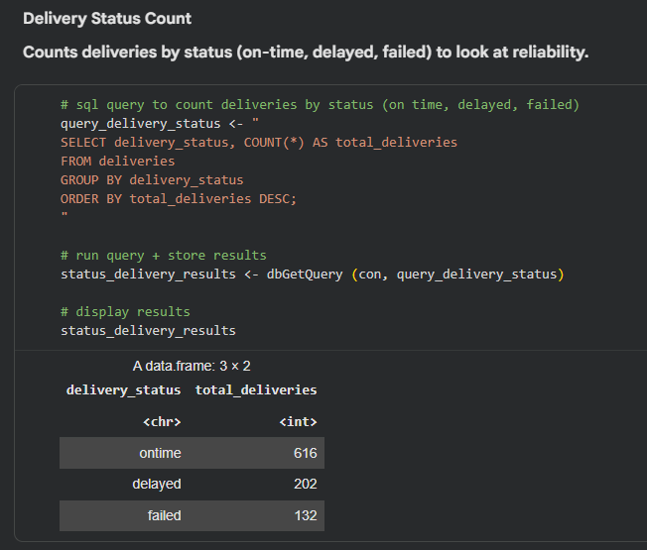
I used another SQL query to identify the customer rating average for delivery statuses. Here, a 4.2 rating was provided for on time deliveries, 3.14 for delayed and 3.06 for failed. The conclusion is that delivery issues have a negative impact on customer experience. This means that the analysis of reliability and customer unhappiness will be required.
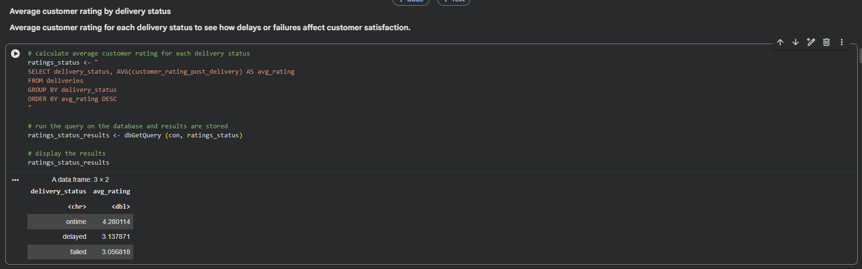

An SQL join query was done using the two tables which are ‘orders’ table and ‘deliveries’ table based on order_id, which is the common attribute for both tables. The analysis was used to determine the delivery performance according to the nature of the service. Passenger services for instance had 171 on time deliveries, 53 late deliveries and 38 failed deliveries, parcel services had 156 on time deliveries, 49 late deliveries and 25 failed deliveries. It can be observed that there are varying delivery performance issues and that cross table analysis is needed by NorthStar to solve these problems operationally.
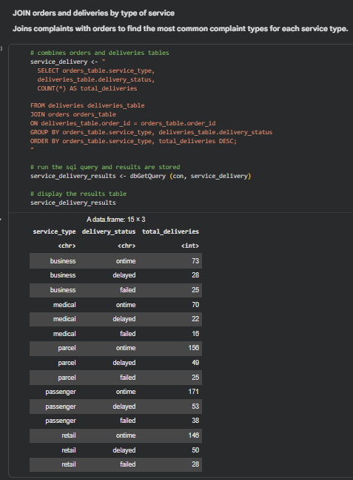

The analysis on average battery health according to whether a vehicle was in repair, active or scheduled involved querying vehicle data from the database. The outcome of the analysis was that vehicles that were in repair had an average battery health of about 76.64%, those that were active had about 76.71% and those that were scheduled had about 77.67% average battery health.
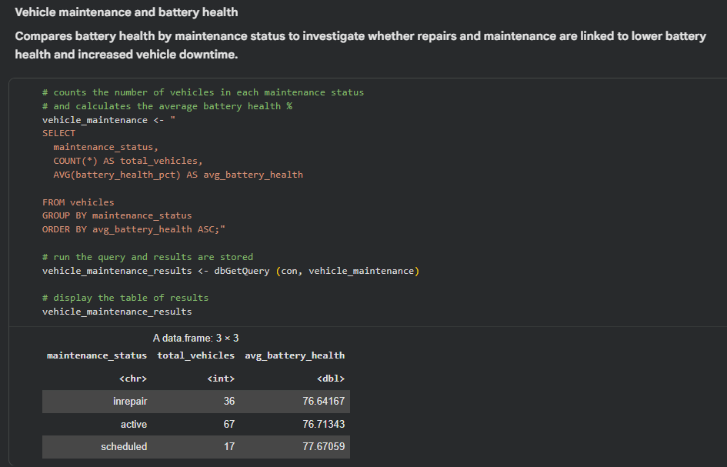

I used indexing on stuff that were mainly used for searching and joining, such as:
    - order_id in orders, deliveries and complaints tables
    - customer_id in customers table
    - delivery_status in deliveries table.
Also, I used EXPLAIN QUERY PLAN to investigate further into SQLite’s execution plan on certain queries. In the case of the delayed delivery query, SQLite used the index called ‘deliveries_status_index’, evident from the output SEARCH deliveries USING INDEX deliveries_status_index. This clearly indicates that the indexing of the delivery_status field was done. In the case of join operation between deliveries and orders, SQLite scans the deliveries table and searches the orders table using the index ‘orders_id_orders’.
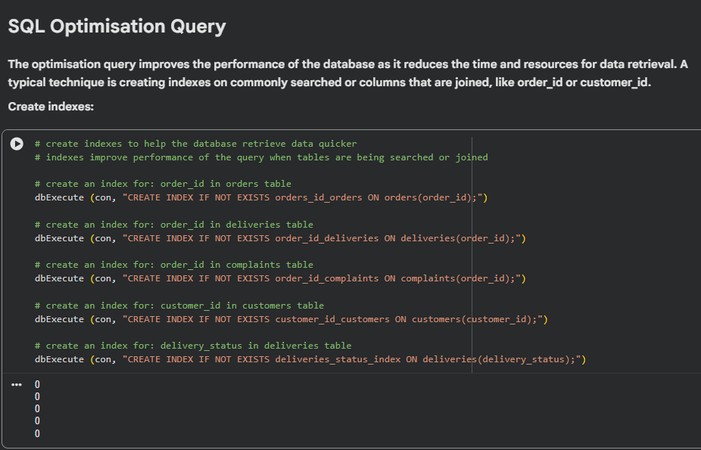

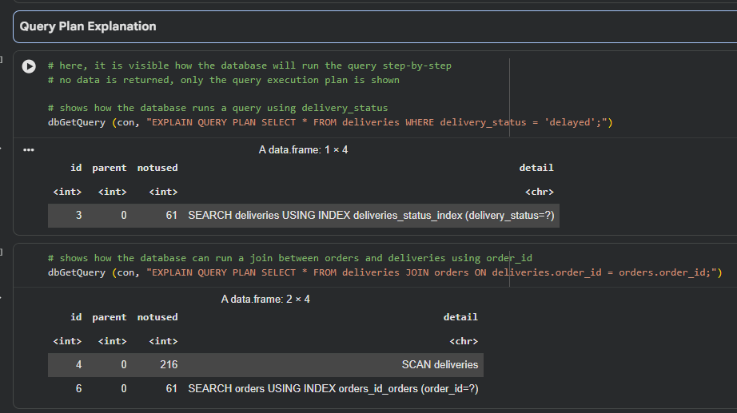
In conclusion, the SQL in R analysis demonstrated that structured querying would be important in linking NorthStar operations’ data in terms of orders, deliveries and vehicles. Structured query language provided insight into demands, delivery problems, client satisfaction, service performance and vehicle fleet status. This proves the point in the case study that there is a need for integrated querying in NorthStar operations.

R Analytics and Visualisation Findings:
As part of the assignment, I also used R analytics for statistical analysis, data manipulation and visualisation. By using the summary() function, I was able to analyse the customer rating average post-delivery. The minimum rating given was 1.0, whereas the mean average post-delivery was 3.867.
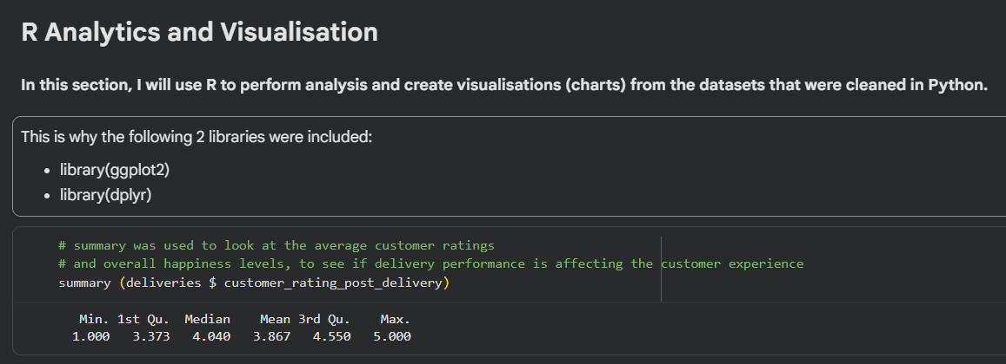

This process was necessary since the deliveries dataset included all the individual delivery instances, but the average customer rating was not provided for each delivery status. According to my analysis, the on-time deliveries had the highest rating compared to other statuses such as delayed and failed. A graph was plotted to illustrate this observation.
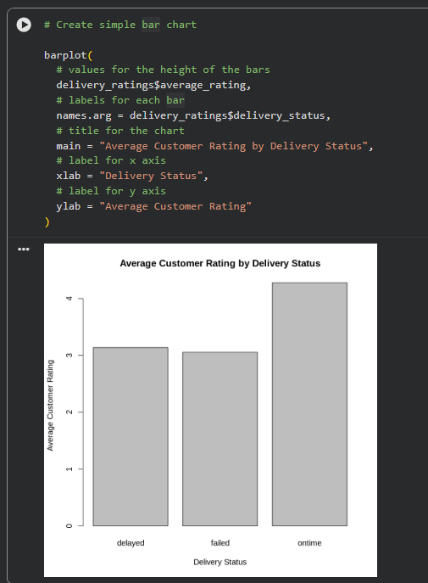

Another summary table recorded the number of deliveries within the different statuses of delivery. It was noted that the most deliveries occurred in good time, however, the number of delayed deliveries was 202, while the failed deliveries equalled to 132. To differentiate the number of on time, delayed and failed deliveries, a bar chart was created for NorthStar to highlight the poor delivery service reliability.
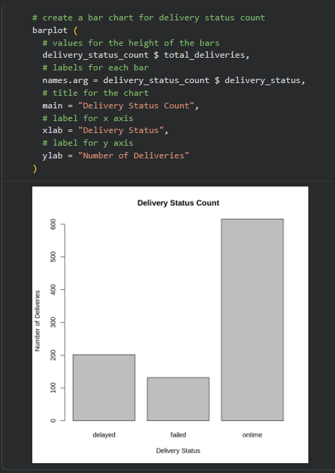

Types of complaints were also recorded using R. The results indicated that delay is the leading type of complaint, with 101 complaints. The second type is that of missed pickup, which had 64 complaints, while application problem was 53 and driver behaviour totalled to 51 complaints. This analysis is significant in that customer unhappiness is mainly due to service reliability and performance levels operationally.
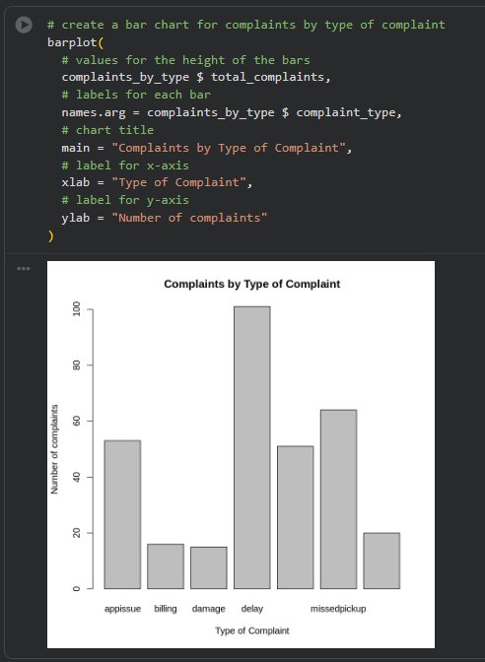

Battery health of vehicles was investigated based on their maintenance status. Battery health was consistent among active vehicles, vehicles under repair and those due for maintenance, at approximately 76% to 78%, respectively. Though the differences are minimal, the analysis can assist NorthStar in tracking its fleet health and identifying any correlations between the maintenance status and battery health, which are important given the case study scenario where there are increased downtime and late discovery of maintenance problems.
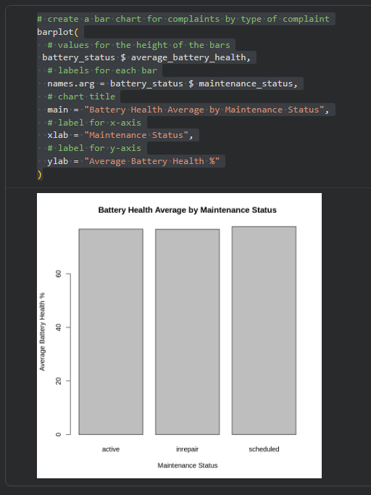

In conclusion, the use of R in the analysis and visualisation section indicates that the operational problems experienced by NorthStar are related to delivery reliability, customer satisfaction, complaints and the health of the vehicles.

MongoDB Atlas and PyMongo Findings
A NoSQL database ‘northstar_db’ was created via MongoDB Atlas. In order to connect to MongoDB using PyMongo and MongoClient, Google Colab was linked to MongoDB. The cleaned CSV files from the GitHub folder names ‘cleaned_csv_files’ were loaded into pandas dataframes to be inserted into the NoSQL database MongoDB.
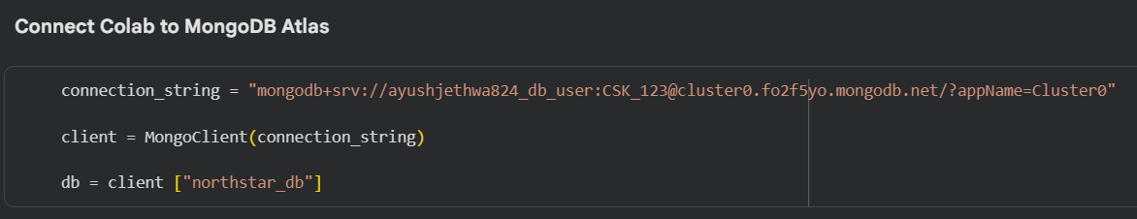
The cleaned CSV files have been loaded into Google Colab prior to the process of inserting them into MongoDB. The size of datasets helped confirm that the correct files were loaded into pandas as per the following data: 650 customers, 1250 orders, 950 deliveries, 320 complaints, 640 app events, 280 incidents, 120 vehicles, 170 drivers and 8 hubs. It was important to ensure that the work in the NoSQL database MongoDB would be performed on the cleaned datasets created in Python.
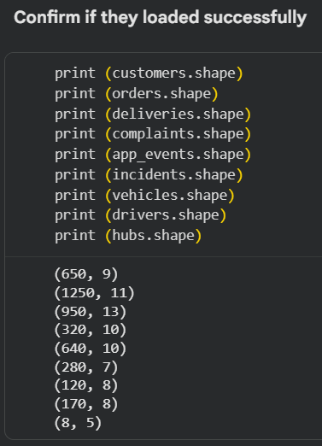

To prevent duplication when running the same notebook multiple times, the old documents in each collection had to be deleted by using ‘delete_many({}). To insert cleaned records, first, they had to be converted into documents using ‘to_dict(“records”).
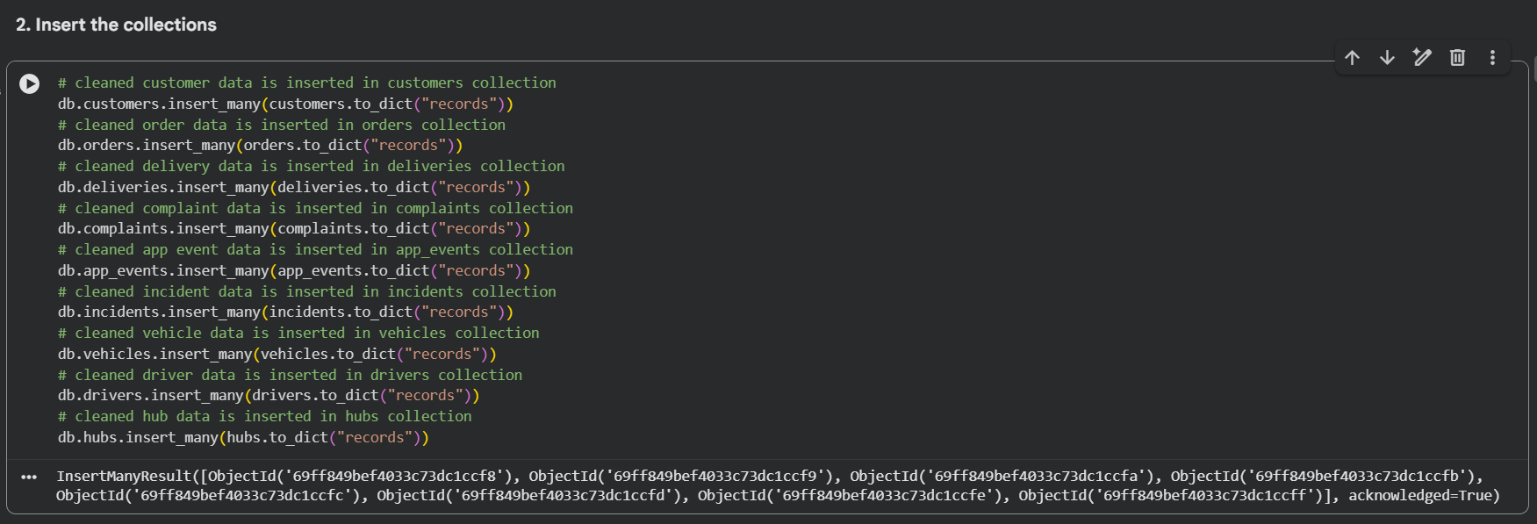
Next, I used ‘count_documents({}) to see the number of documents in every collection in MongoDB after being inserted. The number of documents I saw were: 650 customers, 1250 orders, 950 deliveries, 320 complaints, 640 app events, 280 incidents, 120 vehicles, 170 drivers and 8 hubs. This confirmed the successful insertion of the records to MongoDB Atlas based on the clean datasets sizes.
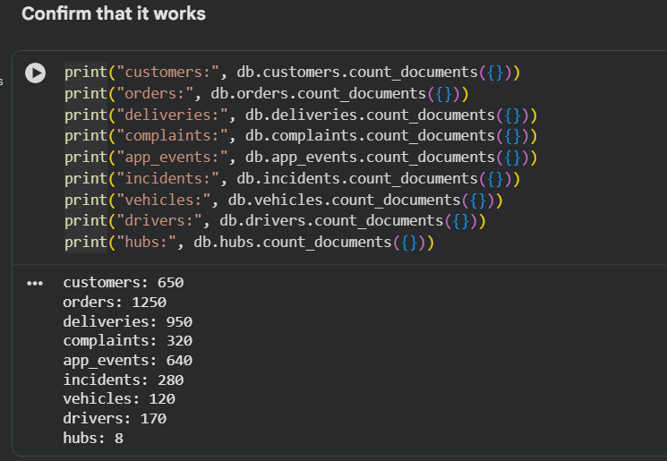

Another NoSQL data model based on the orders and deliveries datasets was proposed, which involved creating a ‘delivery_data’ collection. A document contains one order record along with all deliveries related to that order. This is an example of a simple MongoDB document structure since related records are combined in one document.
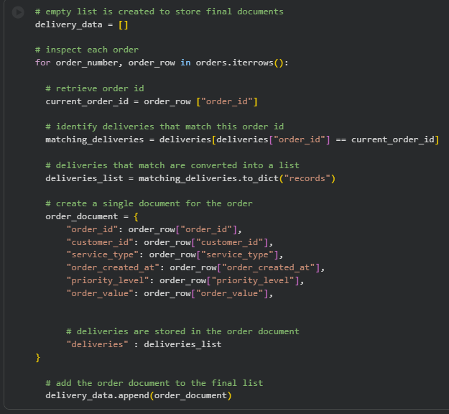
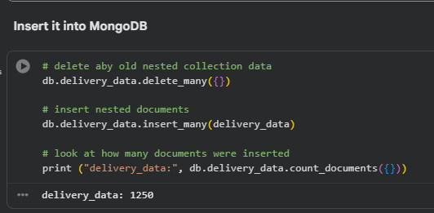

Finally, a document in the ‘delivery_data’ collection was selected and shown by applying ‘find_one()’. Order attributes like ‘order_id’, ‘customer_id’, ‘service_type’, ‘priority_level’ and ‘order_value’ are available from this output. In the same document, one can see the record that shows what happened with the delivery. For NorthStar, this type of data storage helps their employees access information about an order and its delivery status.
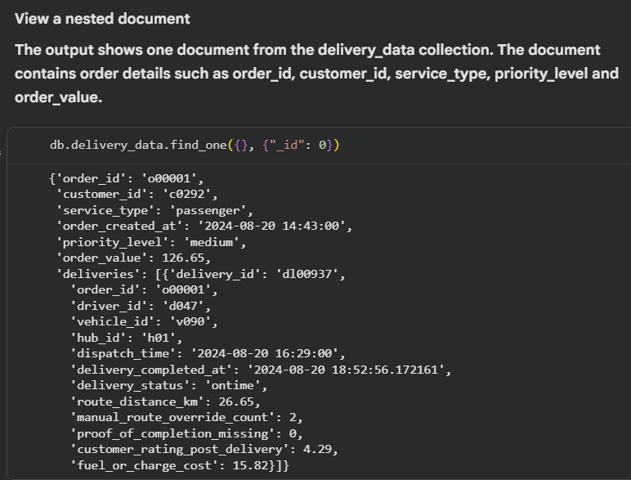

CRUD operations were demonstrated using a sample service case in the service_cases document. The create operation was demonstrated by inserting a new case for support using the insert_one() method. UPDATE was utilised by updating the case’s status which was initially set to ‘open’ and was updated to ‘resolved’ using ‘update_one()’. Lastly, DELETE was executed by deleting the sample case using ‘delete_one()’.
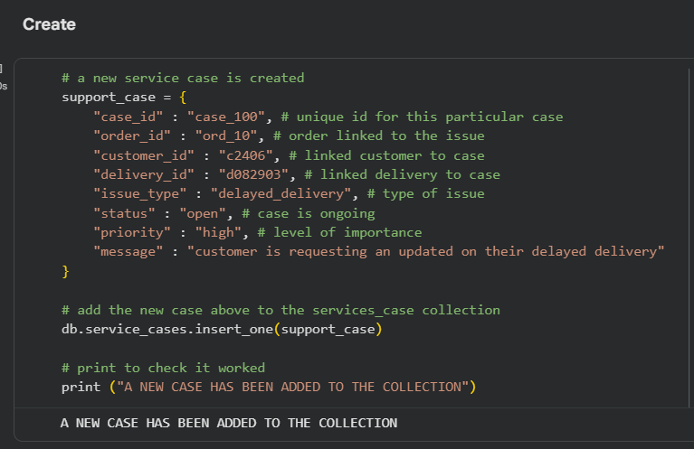
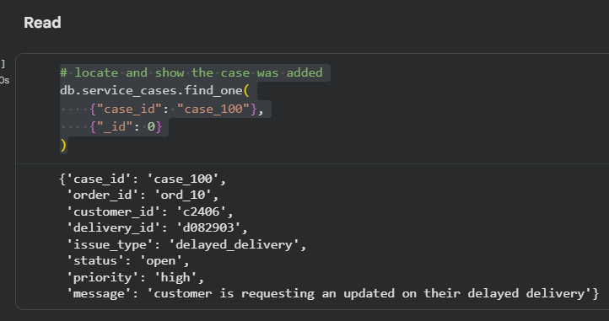
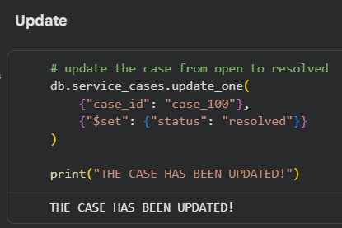
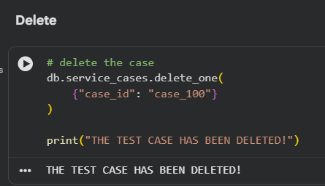

Operational records within the deliveries document were extracted using queries. One query provided information about failed deliveries, while the other query provided information about delays. This resulted in an output that showed selected fields such as ‘delivery_id’ and ‘delivery_status’. The queries can be useful as the NorthStar case study identifies delays, failures of services and missed delivery windows as some of its operational issues.
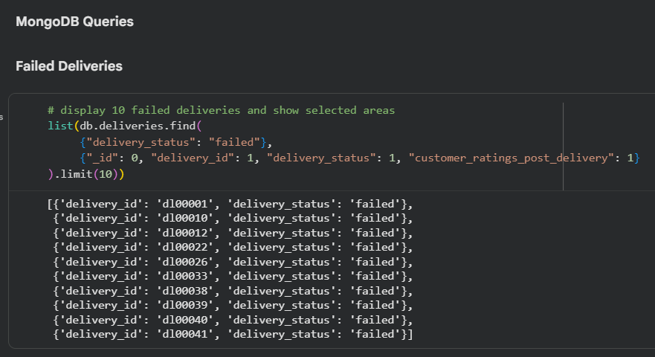
Indexes were created in MongoDB for faster query performance. An index on the ‘delivery_status’ field was created to aid MongoDB in searching for records with delays or failures. Indexes were also created on the ‘order_id’ in deliveries and complaints documents, as well as on ‘customer_id’ in the customers document. MongoDB output included index names such as ‘customer_id_1’.
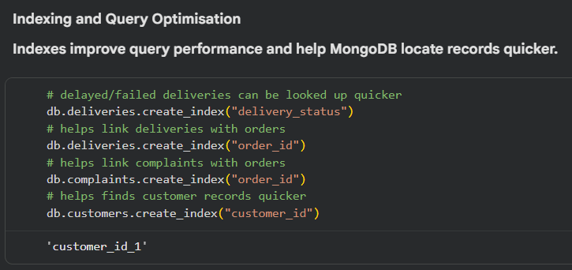

‘explain()’ was also implemented to see how MongoDB optimised the search for delays in deliveries. As seen in the output, ‘IXSCAN’ and ‘Index Name’ of delivery_status_1 is used, which indicates MongoDB uses an index based on delivery_status. 202 records of delayed deliveries were received from the query. This query is an example of query optimisation as MongoDB uses indexes to perform a search and not only scans a whole collection.
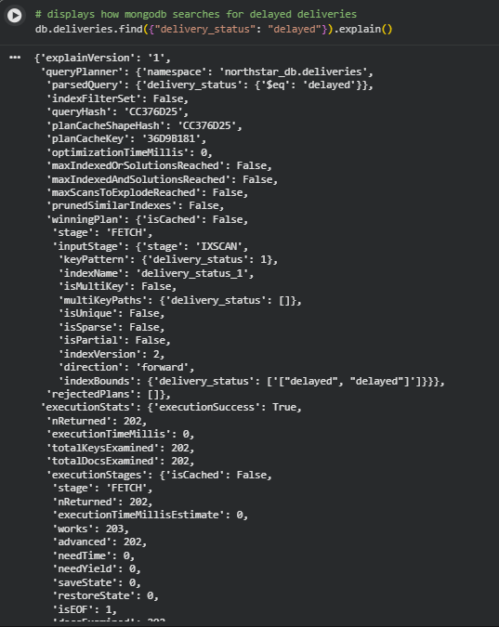

In general, MongoDB was covered through practical application of cleaning of operational data by NorthStar and storage in NoSQL database using Python and PyMongo. In detail, there was cleaning of the data and then adding the clean records to MongoDB collections, creation of a delivery_data collection, performing CRUD operation on MongoDB Atlas databases, retrieving delay or failed delivery information, creation of indexes and explaining the query optimisation process with the help of explain().

Evidence for MongoDB Atlas:

CUSTOMERS:
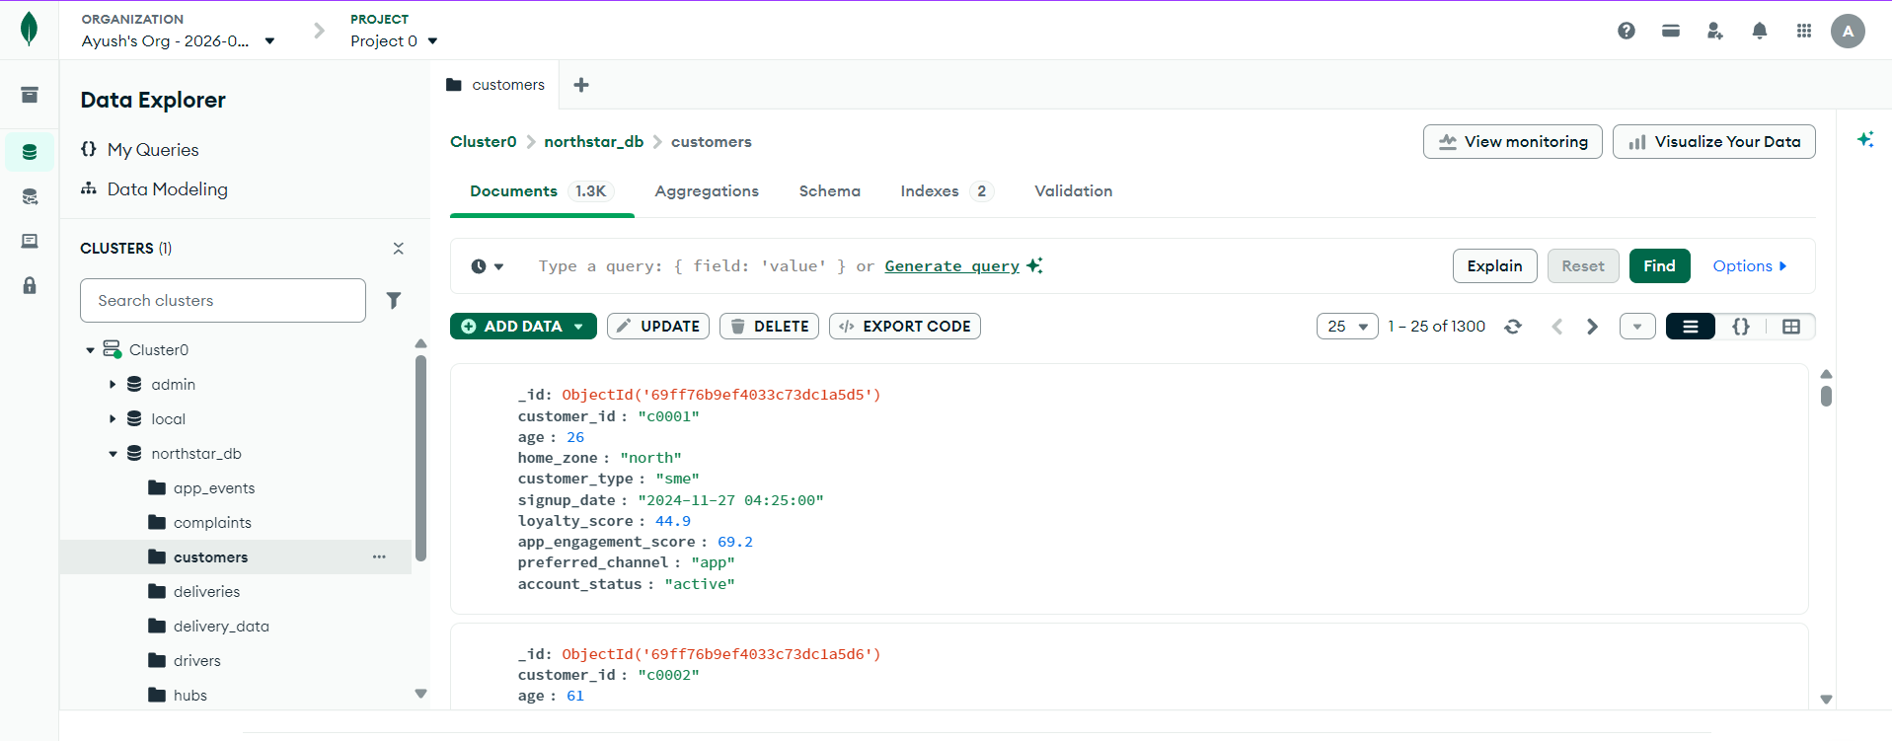

DELIVERIES:
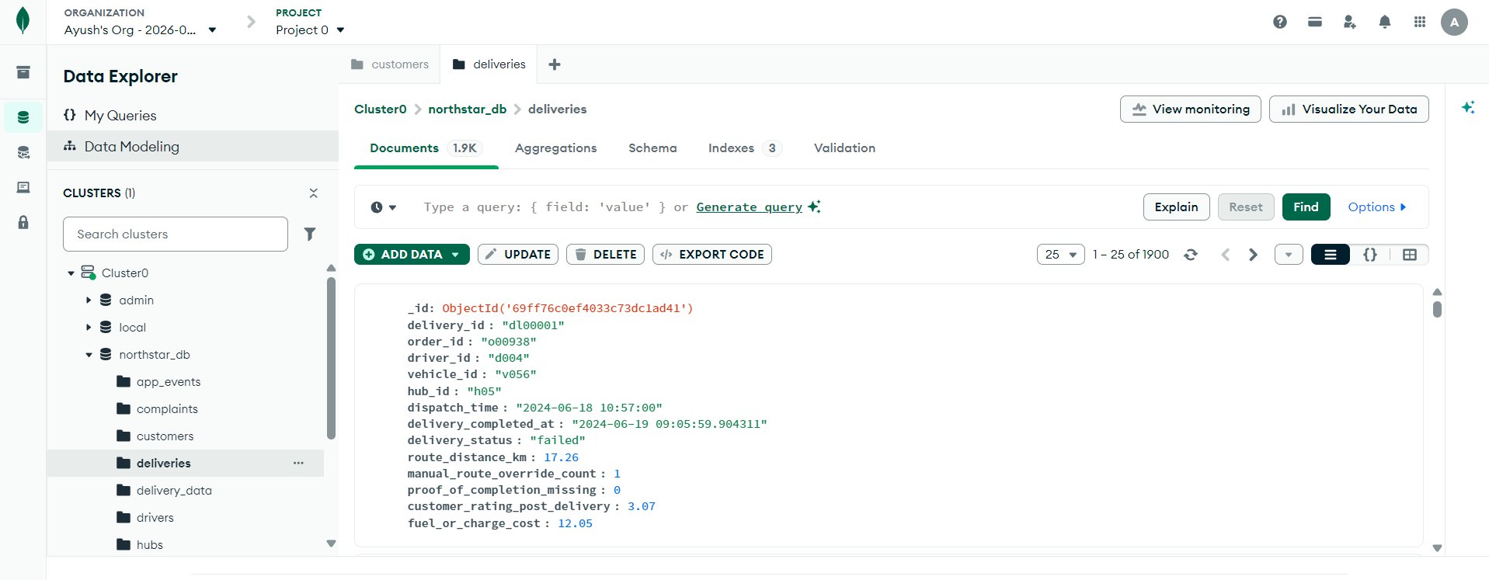

DRIVERS:
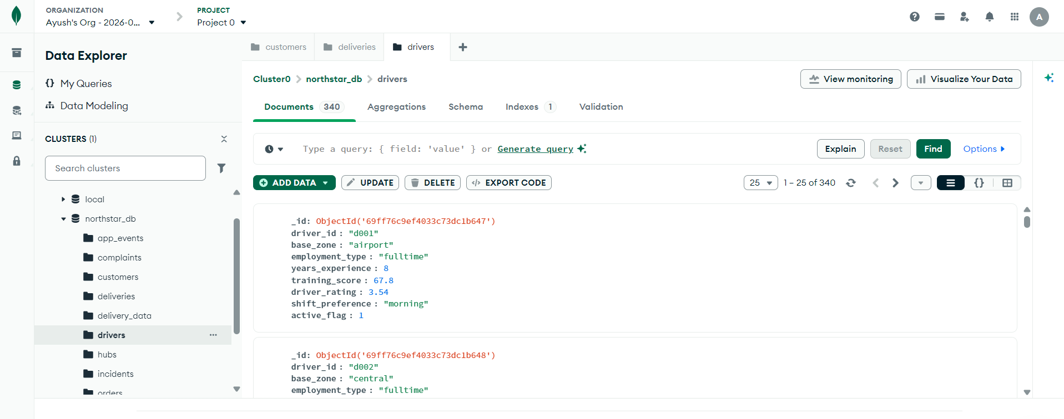

ORDERS:
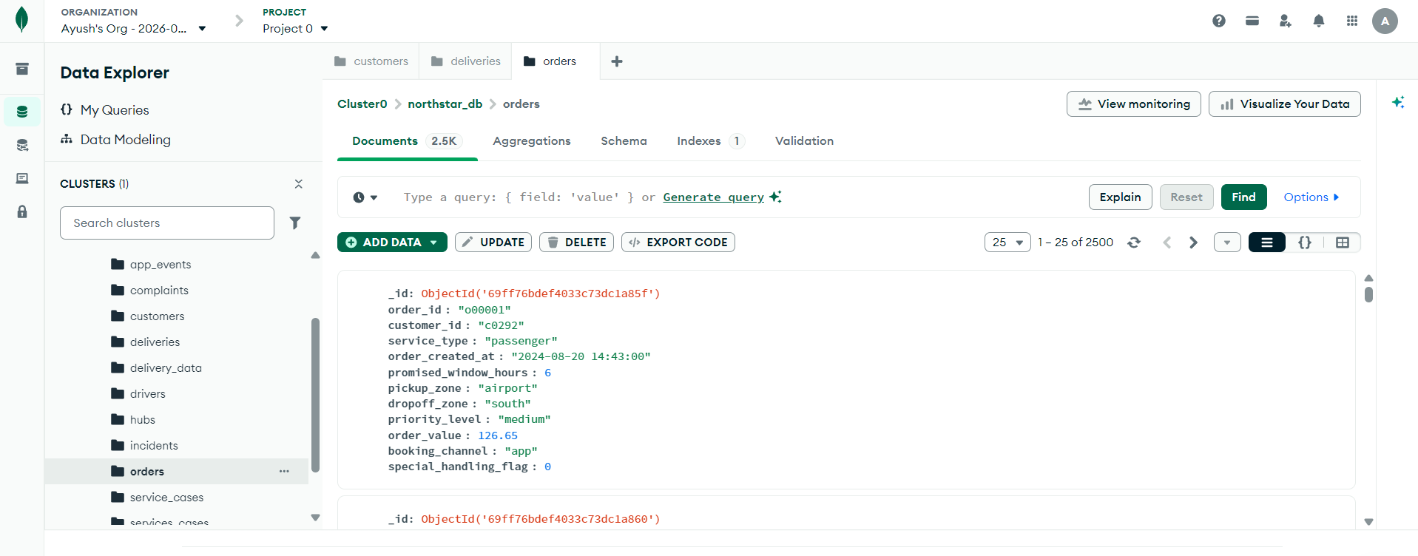

VEHICLES:
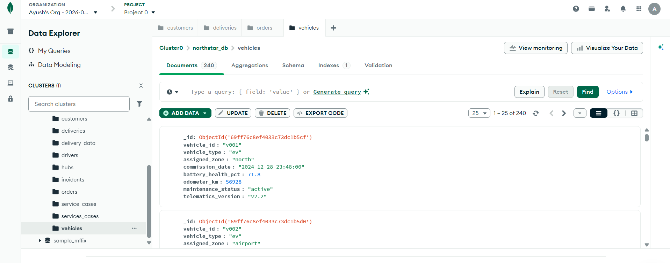

Conclusion
Through this coursework, it was shown how Python, SQL in R, R and MongoDB Atlas were combined to analyse NorthStar’s fragmented operational data. Python helped in loading, analysing, cleaning and visualising the datasets. SQL in R was helpful in querying the structured data, as well as grouping, joining and optimising queries. R was helpful in obtaining summary statistics and visualisations related to customer ratings, delivery status, complaints and vehicle battery. MongoDB Atlas was helpful in setting up a NoSQL database via PyMongo, where collections, a nested delivery_data collection, CRUD, queries, indexing and explain plans were implemented.

Generally, the key problems at NorthStar are those related to delayed and failed deliveries, customer complaints, poor reliability, inadequate documentation operationally and poor vehicle health. From the analysis, my recommendation is for NorthStar to upgrade data integration between order data, delivery data, complaint data, vehicle data and application data so that decisions can be made easily.

